# JS Advanced: Exam 18 March 2018

Problems for exam preparation for the [“JavaScript Advanced” course @ SoftUni](https://softuni.bg/courses/javascript-advanced). Submit your solutions in the SoftUni judge system at <https://judge.softuni.bg/Contests/756/>. //TODO: Change to current exam contest

# Problem 1. Restaurant Bill (Simple DOM Interaction)

You are given the following **HTML code**:

|  |
| --- |
| restaurant-bill.html |
| <!DOCTYPE **html**> <**html lang="en"**> <**head**>  <**meta charset="UTF-8"**>  <**title**>Restaurant Bill</**title**>  <**style**>  **body** {  **padding**: 30**px**;  }  **table**, **section** {  **border**: 1**px solid black**;  **border-collapse**: **collapse**;  }  **th**, **td** {  **padding**: 5**px** 20**px**;  }  **th**, **tfoot td** {  **background**: **#cccccc**;  }  **tr**:**nth-child**(**odd**) {  **background**: **#eeeeee**;  }  **tr**:**nth-child**(**even**) {  **background**: **#dddddd**;  }  **tfoot** > **tr td** {  **font-style**: **italic**;  **font-weight**: **bold**;  }  **section** {  **margin-top**: 10**px**;  **width**: 177**px**;  **background**: **#cccccc**;  }  **section** > **\*** {  **display**: **block**;  **padding**: 5**px**;  }  **h3** {  **margin**: 0;  **text-align**: **center**;  }  **button** {  **margin**: 5**px auto**;  }  </**style**>  <**script src="https://code.jquery.com/jquery-3.3.1.min.js"**></**script**> </**head**> <**body**>  <**h2**>Restaurant Bill</**h2**> <**table id="bill"**>  <**thead**>  <**tr**>  <**th**>Product</**th**>  <**th**>Price</**th**>  </**tr**>  </**thead**>  <**tbody id="product-list"**></**tbody**>  <**tfoot**>  <**tr**>  <**td**>Total:</**td**>  <**td**>0.00</**td**>  </**tr**>  </**tfoot**> </**table**>  <**section id="add-product"**>  <**h3**>Add new product</**h3**>  <**label**>Product:  <**input type="text"**>  </**label**>  <**label**>Price:  <**input type="number"**>  </**label**>  <**button onclick="***addProduct*()**"**>Add</**button**> </**section**>  <**script**>  **function** *addProduct*() {    } </**script**>  </**body**> </**html**> |

### Your Task

**Write the missing JavaScript function addProduct()** to make the **[Add]** button work as expected – when clicked **adds** the new product’s information to the restaurant bill. The **[Add]** button should:

* **Append** the **text** received from the **input boxes** as a **new** **row at the end** of the **table’s body**
* **Add** the **new** **product’s price** to the **total** sum
* **Clear** the **input boxes** after the **product’s information** is **submitted**
* **Do nothing** if **either** of **text boxes** is **empty**

### Submission

Submit only your addProduct function.

**Scroll down** for examples.

### Examples

**First example:**

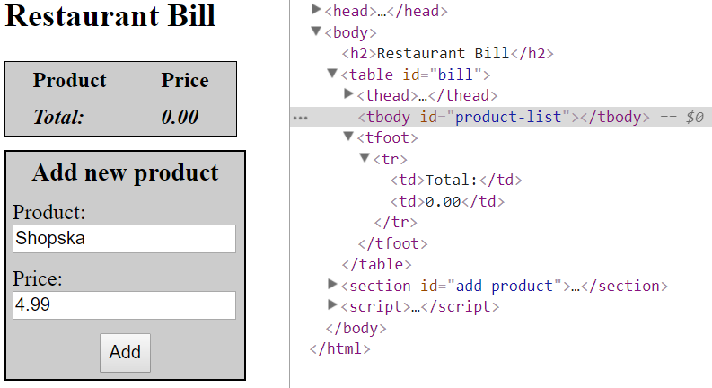

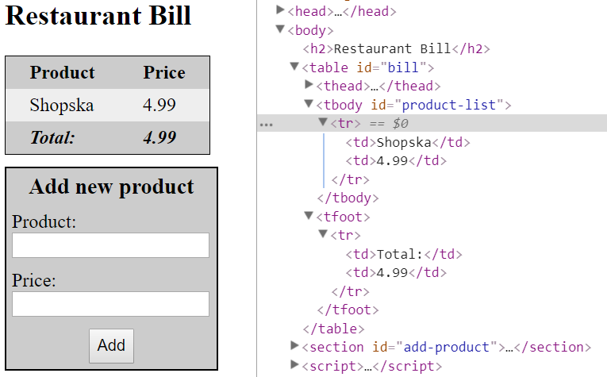

**Scroll down** for more examples.

**Second example:**

